**CONTENT**

|  |  |  |
| --- | --- | --- |
| **S.No.** | **CONTENT** | **PAGE No.** |
| 1. | Abstract | 2 |
| 2. | Project Overview | 3 |
| 3. | System Design | 4 |
| 4. | System Flowchart | 5 |
| 5. | Input Design | 8 |
| 6. | Output Design | 8 |
| 7. | Menu Level Description | 9 |
| 8. | Process Specification | 10 |
| 9. | Screen Layouts | 11 |
| 10. | Conclusion | 13 |
| 11. | Bibliography | 14 |

**ABSTRACT**

# The Courier Management System is a comprehensive and user-friendly web application designed to digitize and streamline the internal operations of courier service providers. With the growing demand for efficient logistics and the need for real-time communication between hubs, this system aims to centralize and secure access to contact details of various courier hubs across regions. The platform provides a secure user login interface that restricts unauthorized access and ensures that only verified users can interact with sensitive hub-related information.

# Developed using modern web technologies like HTML, CSS, and JavaScript, the system emphasizes simplicity, responsiveness, and modular design. The login module performs credential validation, after which users are directed to a central dashboard displaying hub-wise contact details including address, mobile number, and email. Each contact is neatly displayed in card format, improving visibility and allowing for faster decision-making.

# One of the key benefits of this system is its scalability. While it currently focuses on viewing hub information, its structure supports future integration with modules such as shipment tracking, performance monitoring, and customer support ticketing. This makes the Courier Management System a foundational tool for courier organizations aiming to modernize their operations and maintain effective inter-hub communication.

# By reducing reliance on manual documentation and paper records, the system not only increases operational efficiency but also ensures data integrity, improves access speed, and minimizes errors. Its structured layout promotes clarity, while its adaptability ensures long-term relevance in dynamic logistics environments. The solution is ideal for both small-scale courier businesses and large-scale logistics networks looking to embrace digital transformation.

# INTRODUCTION

### PROJECT OVERVIEW

The project entitled Courier Management System is a lightweight, modular, and user-centric web application designed to streamline and digitize the management of regional courier hub contact details. This system focuses on automating the process of accessing and managing hub-wise contact information, such as addresses, mobile numbers, and official email IDs, through a secure, role-based login mechanism.

The platform ensures that only authorized users can log in and access the dashboard, maintaining the confidentiality of internal hub data. Once authenticated, users are redirected to a centralized interface where they can view structured hub information in an easily navigable card-based format. The logical flow begins with credential validation, followed by dashboard access, and culminates in the display of real-time hub contact information.

Key modules include a secure login form, a hub-wise contact detail dashboard, and responsive layout components that ensure compatibility across devices. The system’s streamlined design enhances operational readiness by enabling logistics teams and customer support agents to quickly retrieve essential contact details during dispatches or service coordination.

By reducing reliance on outdated, manual records and unstructured spreadsheets, the Courier Management System promotes data accuracy, ensures faster decision-making, and fosters improved inter-hub communication. The application lays a solid foundation for future integration with delivery tracking, route mapping, and customer support modules, thereby providing a scalable digital solution for modern courier operations.

## 2. SYSTEM DESIGN

### 2.1 INTRODUCTION

System design is the process of defining the architecture, components, modules, interfaces, and data structures that collectively fulfill the specified requirements of a software system. It represents the transition from understanding what a system needs to do (as identified in system analysis) to figuring out how to achieve those requirements in a structured and efficient manner. While system analysis answers the “what is” question, system design addresses the “how to” aspect of building or improving a system.

This phase plays a critical role in shaping the success of the project. It involves not only outlining technical solutions but also ensuring that these solutions align with the operational and strategic goals of the organization. System design takes the recommendations from the feasibility study and converts them into a comprehensive blueprint for development, laying the groundwork for the implementation phase.

Before diving into system design, careful planning is essential. It is important to conduct a thorough analysis of the existing system—understanding its limitations, inefficiencies, and pain points—to identify how the new or upgraded system can bring about measurable improvements. This involves evaluating how the integration of computing technologies can enhance overall performance, reduce manual effort, and streamline workflows.

The significance of system design lies in its impact on quality. Design is where the foundation for high-quality software is built. A well-crafted design not only meets user requirements but also ensures maintainability, scalability, security, and efficiency of the system. It acts as a communication bridge between the end-users and the developers by transforming user-oriented documentation into technical specifications that can be interpreted and implemented by programmers, database administrators, and system architects.

Moreover, system design is both a technical and creative endeavor. It demands a blend of analytical thinking, problem-solving, and innovation to architect a solution that is technically feasible, economically viable, and user-friendly. It also includes considering user interfaces, data flows, control logic, and hardware-software integration, all of which contribute to a system that is robust, adaptable, and efficient in meeting its intended purpose.

In summary, system design is not just a step in the development cycle—it is the foundation of a successful and sustainable software product. A strong design ensures that the final system is reliable, efficient, and tailored to meet user expectations and institutional objectives.

### 2.2 SYSTEM FLOWCHART

The classical system flowchart approach to describing and documenting a system will be presented. These system flowcharts are also used in the structured approach that is, form the general to detailed, of the system development life cycle.

Because they have been used to describe system for many years, they are still common in many businesses.

**Basic Flow chart Symbols:**

Process

Input - Output

 Connector

Off page Connector

Data Flow

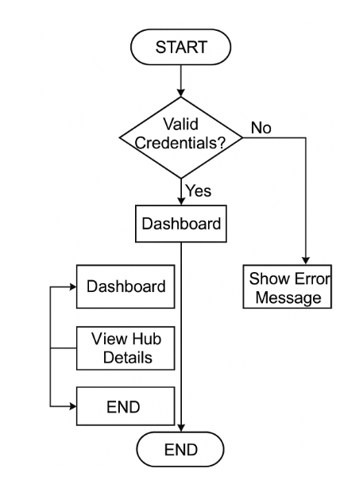

**Fig 2.1 Courier Management System Flow Chart**

**Fig 2.1** The operational flow of the Courier Management System is centred on secure user authentication and structured navigation through role-based access. The system workflow begins with the login process, where the user is prompted to enter their credentials on the login page.

The first decision point in the flow involves verifying the validity of the entered credentials. If the login credentials are invalid, the system halts further access and presents the user with an error message, ensuring that unauthorized users are not granted access to sensitive system data.

If the credentials are valid, the user is successfully authenticated and directed to the **main dashboard**. This dashboard serves as the control centre of the system, providing access to core modules such as:

* **Dashboard Overview** – Acts as the primary interface summarizing system status.
* **View Hub Details** – Displays hub-wise contact information including address, mobile number, and official email ID.

Each module is accessed through a streamlined, user-friendly layout, allowing for quick navigation and retrieval of information. This structured approach ensures that users can interact with the system efficiently while maintaining data security and integrity.

The operational flow concludes when the user either completes their tasks or chooses to log out. This ensures a well-regulated and logically guided interaction with the system, promoting reliability and user accountability in courier hub operations.

### 2.3 INPUT DESIGN

**User (Courier Staff/Admin):**

* **Login Credentials:**
  + **Username:** Unique identifier for the user (text input).
  + **Password:** Secure field for authentication (password-masked input).

**2. Hub Administrator:**

* **Hub Details Entry:**
  + **Hub Name:** Name of the regional courier hub.
  + **Hub Address:** Full address with locality, city, and pin code.
  + **Mobile Number:** 10-digit contact number for the hub.
  + **Email ID:** Official hub email address for communication.

Each input field includes validation checks to ensure proper formatting and completeness before submission.

### 2.4 OUTPUT DESIGN

**User:**

* **Login Status:**
  + Upon entering valid credentials, a popup confirms: “Login Successful! Welcome to Courier Hubs!”
  + Redirects to the dashboard.

**2. Hub Administrator:**

* **Hub Contact Display:**
  + The dashboard shows hub-wise contact information in card layout format.
  + Each card includes:
    - Hub Name
    - Hub Address
    - Mobile Number
    - Email
* **Error Feedback:**
  + If login credentials are incorrect, an error message is displayed.

## 3. SYSTEM DEVELOPMENT

### 3.1 MENU LEVEL DESCRIPTION

###### The Menu Level Description for the Courier Management System is organized as follows:

### 1. Login Menu:

### Homepage:

### The main landing page for users to enter credentials.

### Fields: Username and Password.

### Authentication Result:

### On successful login, redirects to the dashboard.

### On failure, displays an error popup.

### 2. Hub Contact Menu:

### Dashboard:

### Displays a header titled “Hub Wise Contact Details.”

### Provides access to all registered courier hubs.

### Hub Details View:

### Each courier hub is presented in a neatly formatted card.

### Includes key contact information:

### Address

### Mobile Number

### Email ID

### 3. Administrator Functions (optional future module):

### Admin Dashboard:

### Interface to add/edit/delete hub contact records.

### Could be implemented using form-based CRUD operations.

### User Management:

### Manage staff login credentials and roles (future scalability).

### 3.2 PROCESS SPECIFICATION

Process specification is a systematic method used to document, analyse, and explain the logic and rules that govern how input data is transformed into output. In the Courier Management System, process specifications help define the secure authentication mechanism, data flow for viewing hub details, and the logical operations involved in the system’s functionality. High-quality process specifications are essential to ensure consistent behaviour, maintainability, and alignment with operational requirements.

**1. User Authentication:**

**Step 1:**  
Users (courier staff, administrators) enter their credentials (username and password) on the login page.

**Step 2:**  
The system validates the credentials against predefined data or server records.

**Step 3:**

* If valid: The user is granted access to the dashboard.
* If invalid: An error message is displayed.

**2. Dashboard Access:**

**Step 1:**  
After successful login, users are redirected to the Hub Contact Dashboard.

**Step 2:**  
The system loads hub-wise contact data (pre-stored or dynamically fetched).

**3. Hub Details Display:**

**Step 1:**  
Each courier hub’s card is dynamically created and displayed using stored data.

**Step 2:**  
Displayed details include:

* Hub Name
* Address
* Mobile Number
* Email ID

**4. Access Control:**

**Step 1:**  
Only authenticated users are allowed to access hub details.

**Step 2:**  
Non-logged-in users are restricted from entering the dashboard or viewing internal hub data.

**5. System Maintenance and Scalability:**

**Step 1:**  
The system allows for easy updates such as:

* Adding new hubs
* Modifying contact info layout

**Step 2:**  
Future versions may support:

* Admin interface for CRUD operations on hub data
* Integration with shipment tracking systems
* Enhanced role-based access for different user types

**4. SYSTEM TESTING**

**4.1 SCRREEN LAYOUTS**

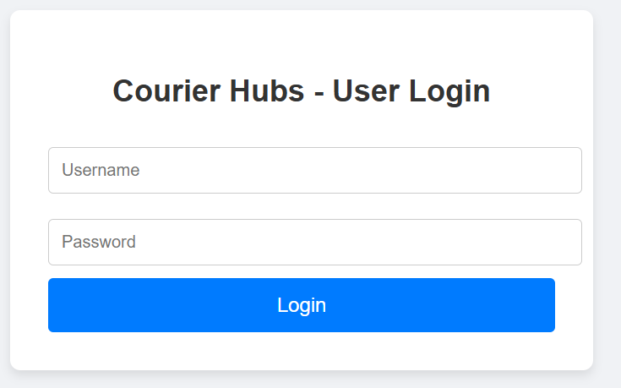

#### Courier Login Page

#### 

#### Courier Login Success Popup

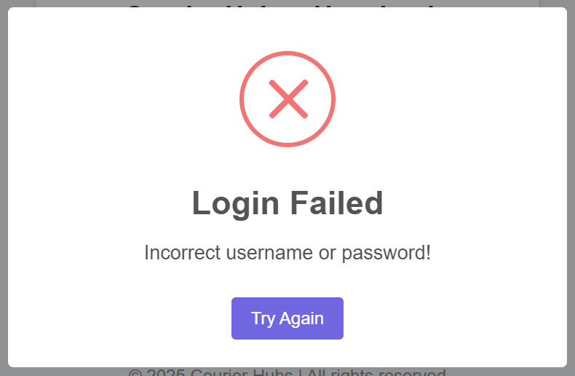

#### Courier Login Failed Popup

#### 

#### Hub Wise Contact Details

## 5. CONCLUSION

The Courier Management System serves as a robust, scalable, and highly efficient tool designed to improve communication and information management across regional courier hubs. By enabling secure access to essential hub contact details and presenting them in a structured and intuitive interface, the system significantly enhances operational coordination within logistics organizations.

Its secure login mechanism ensures that only authorized personnel have access to the data, thus protecting organizational privacy and reducing the chances of unauthorized information dissemination. The hub dashboard offers real-time access to contact information, reducing the time taken by customer service agents and field executives to locate relevant hub details.

Additionally, the system's modular structure paves the way for future enhancements such as integration with GPS tracking systems, role-based admin panels, dynamic shipment status updates, and digital delivery records. These enhancements would further improve productivity, increase transparency, and allow courier companies to deliver a more reliable and tech-savvy service to their clients.

By digitizing a critical part of the courier workflow, the system eliminates bottlenecks caused by outdated processes. It empowers logistics personnel to make informed decisions faster, streamlines inter-hub communications, and supports continuous improvements in service quality.

In conclusion, the Courier Management System stands as a valuable technological solution in the logistics sector, promoting efficiency, accountability, and scalability. It not only addresses current operational needs but also prepares courier organizations for future digital integration and intelligent logistics management.

## 6. BIBLIOGRAPHY

1. OpenAI: "GPT-3: Language Models for Text Generation." https://[www.openai.com](http://www.openai.com/)
2. GeeksforGeeks: "Computer Science Portal." [https://www.geeksforgeeks.org](https://www.geeksforgeeks.org/)
3. YouTube: “Various Tutorials and Educational Content." https://[www.youtube.com](http://www.youtube.com/)